**10 Heuristic Principles**

1)Visibility of the system status ( always the user needs to be shown the status of the job doing).

If there is low internet connectivity, it should prompt that the email is loading

2)Match between the system and real world (Eg: recycle bin, ibooks app (looks like book shelf)

3) User Control and Freedom

4) Error prevention ( Prompt sending mail without subject, attachments)

5) Help user recognize, diagonize are recover from errors (delete prompt)

6) Maintaining the consistency

7) Recognition rather than recall

8) Flexibility and efficient use

9) Aesthetic and minimalist design

10) Help and Documentations

Sign in Page

User name 🡪 [ Highlights us what to enter in the user name ]

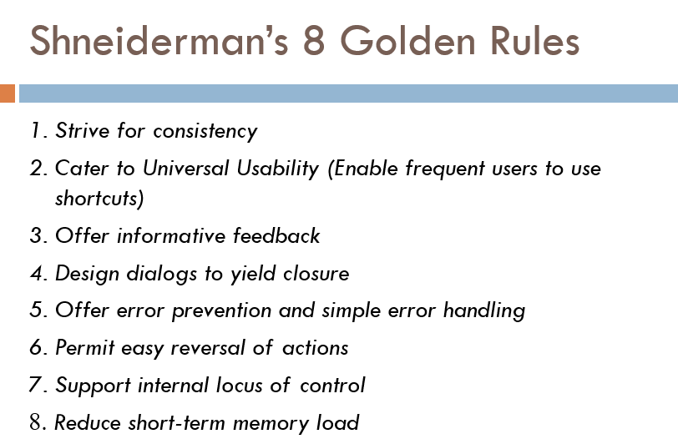

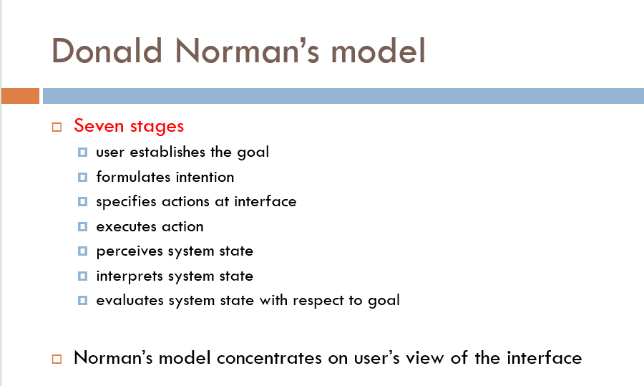

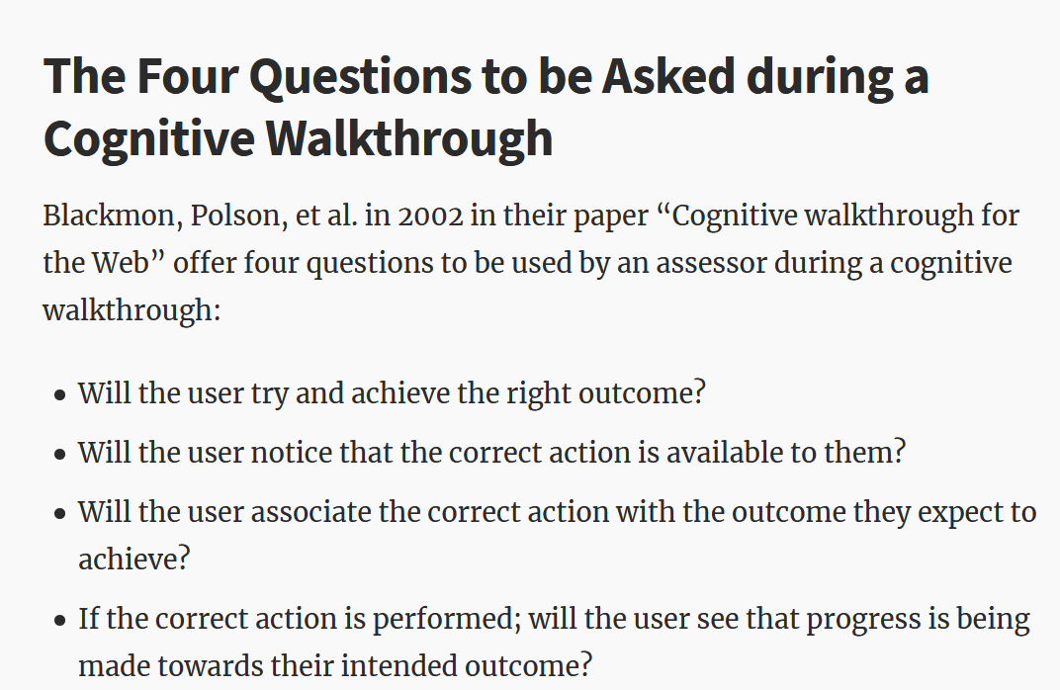

Windows presentation styles 🡪 Tiled,overlapping,cascading

<http://www.brainkart.com/article/Window-Presentation-Styles_9032/>

Modal and Modeless windows 🡪 <https://webdesign.tutsplus.com/articles/modal-and-modeless-boxes-in-web-design--webdesign-2282>

List box (vs) Drop down/pop-up list box 🡪 <https://www.nngroup.com/articles/listbox-dropdown/>

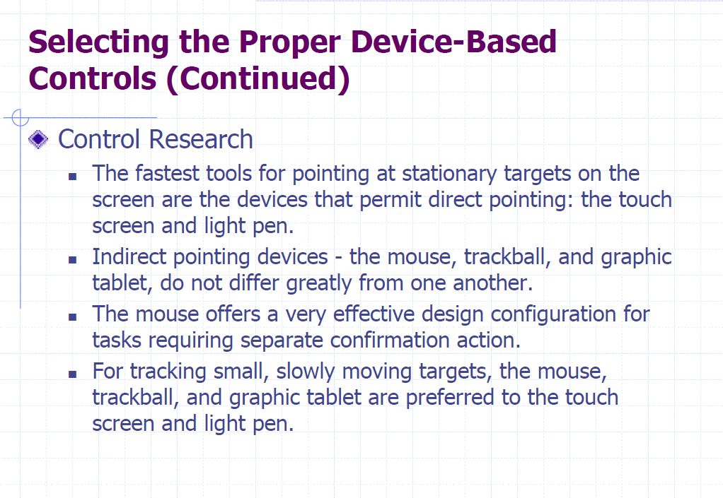

Command buttons

